|  |
| --- |
|  |
| SPSS Analysis |
|  |

|  |
| --- |
|  |

Table of Contents

1. Introduction 3

2. SPSS Analysis 3

3. Chart-based Data Analysis 3

4. References 32

Table of Figures

Figure 1:Gender 3

Figure 2:Age Analysis 4

Figure 3:Education qualification 5

Figure 4: Employment Status 6

Figure 5:Monthly income 7

Figure 6:Residential province 8

Figure 7:Are you purchasing daily goods from Supermarkets 9

Figure 8:If yes, what are the major supermarkets that the Person is Using 10

Figure 9:I want to purchase FMCG (fast-moving consumer goods) products in supermarkets 11

Figure 10:I will purchase FMCG products from supermarkets in the near future 12

Figure 11:Recommendation to Purchase FMCG Products from Supermarkets 13

Figure 12:Recommendation to Purchase FMCG Products from Supermarkets 14

Figure 13:I Look for in-store advertisements 15

Figure 14:Promotional offers and signage in Supermarkets gain my attention 16

Figure 15: Purchase of FMCG products based on the special offers that are put inside stores 17

Figure 16:I purchase more FMCG products unintentionally which are on sale 18

Figure 17:The promotional display attract me to visit the supermarket again 19

Figure 18:Brightly lit supermarkets are more attractive than dimly lit stores 20

Figure 19:Good lighting impacts the atmosphere of the supermarket 21

Figure 20:The use of lights in different colors and brightness to decorate the supermarket would attract me to products that are seen and swing my mood toward buying 22

Figure 21:Purchase FMCG products from supermarkets because of the way they are arranged on the shelves 23

Figure 22:When there is an eye-catching display, I end up purchasing that product 24

Figure 23:I like purchasing products that are displayed on the billing counter 25

Figure 24: Purchase products from the supermarket based on the convenience of the product placed 26

Figure 25:A good supermarket layout makes me easy to find desired products 27

Figure 26:Store layout which will allow moving easily 28

Figure 27:I Buy products based only after looking around completely 29

Figure 28:Tend to buy more products that are catchy to me when I pass aisles(passenger pathway) 30

# 1. Introduction

This study examines how visual merchandising strategies affect consumer purchase intent in Sri Lankan supermarkets, focusing on the ***fast-moving consumer goods (FMCG) industry***. Data on customer behavior and preferences concerning visual merchandising methods were gathered for the study utilizing a survey questionnaire. To obtain insightful conclusions, the data was statistically evaluated. For merchants in Sri Lanka, the paper offers valuable guidance on how to use visual merchandising strategies to change consumer behavior and boost buying intentions.

# 2. SPSS Analysis

When working with the dataset, it is important to ensure that the variable names are clear and that the values are assigned appropriately. For example, if the original dataset uses the phrase "strongly agree" to indicate the highest level of agreement, it may be more clear to rename this variable to "agree_5" and assign the value 5 to indicate the highest level of agreement. Similarly, if the original dataset uses the phrase "disagree" to indicate the lowest level of agreement, it may be more clear to rename this variable to "disagree_1" and assign the value 1 to indicate the lowest level of agreement. After updating the variable names and values, it is important to recode any string values to numeric types.

# 3. Chart-based Data Analysis

The survey data can be analyzed by looking at each questionnaire question separately and then using the appropriate charts or graphs to depict the results graphically. The interpretation and discussion of the collected data can subsequently be facilitated by the graphical displays

1. 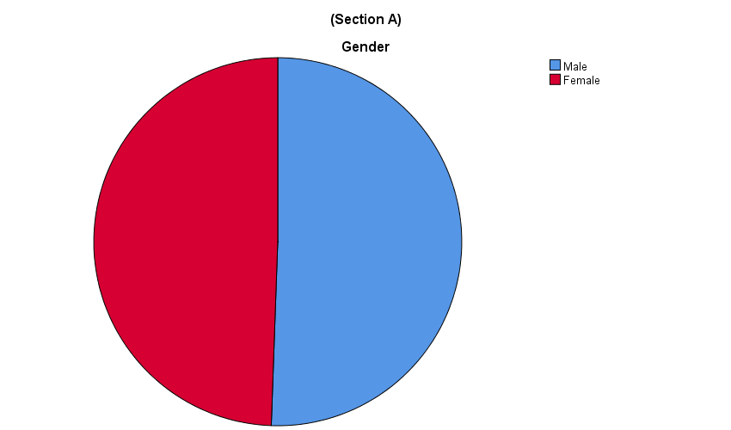**Gender**

Figure 1:Gender

As data were obtained from this survey, approximately equal numbers of males and females participated.

1. **Age Analysis**

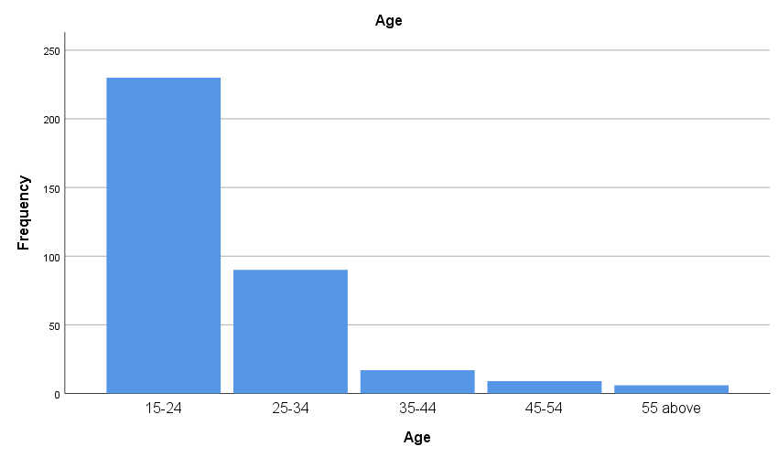

Figure 2:Age Analysis

The information shows how old each survey respondent was. A total of ***352*** participants gave honest answers to the query. ***65.3%*** of the sample's responses, or the majority, were between the ages of ***15 and 24***.

***25.6%*** of the sample's participants were 25 to 34 years old, whereas ***4.8%*** of the sample's participants were ***35 to 44***.

***4.6%*** of the participants were 45 years of age or older. With more than ***90%*** of the participants under 35, the findings show that the survey sample is skewed toward younger age groups.

1. **Educational Qualification**

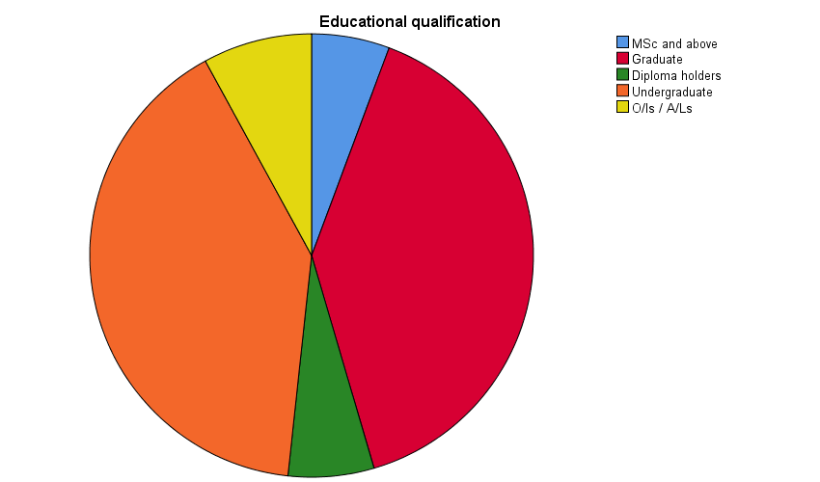

Figure 3:Education qualification

The information reflects the participants in the survey's level of education. A total of 352 participants gave honest answers to the query. Undergraduate students made up the majority of respondents, making up ***40.3%*** of the sample, followed by graduate students at ***39.8%.*** Participants who held diploma-level credentials made ***up 6.3%*** of the piece, while those with MSc-level degrees made up 5.7% of the model. The remaining 8% of the participants were O/L and A/L holders. According to the data, the survey sample is primarily made up of those pursuing higher education, with over 85% of the participants holding undergraduate or higher degrees.

1. **Employment Status**

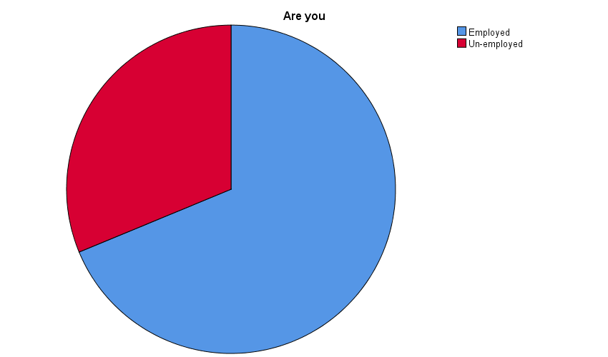

Figure 4: Employment Status

According to the data collected, the majority of the participants are employed.

1. **Income level**

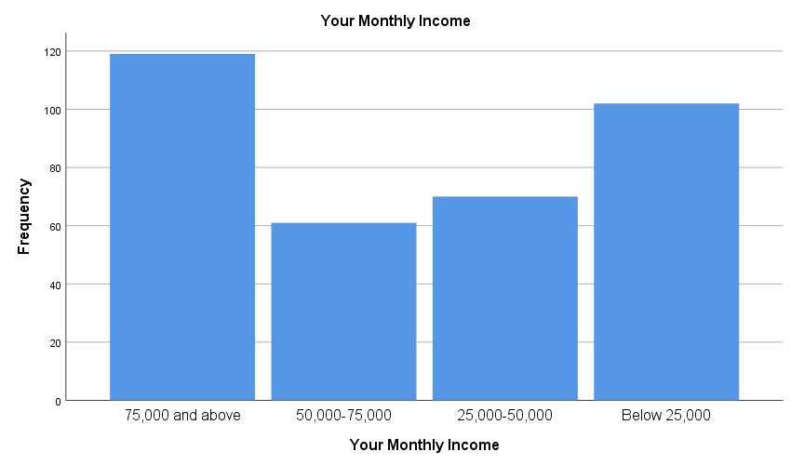

Figure 5:Monthly income

The information shows how much each survey respondent made each month. ***33.8%*** of the sample, or the majority of respondents, stated that their monthly income was at least ***75,000*** Sri Lankan rupees. Participants who reported having a monthly income of ***50,000 to 75,000*** Sri Lankan Rupees made up ***17.3%*** of the sample, while those who reported having a monthly income of ***25,000 to 50,000*** Sri Lankan Rupees made up 19.9% of the piece.

The remaining ***29%*** of the model were people who had a monthly income of less than 25,000 Sri Lankan Rupees. According to the data, the survey sample is diversified in terms of average monthly income, with a relatively equal percentage of respondents falling into each of the several income quartiles.

1. **Residential Province**

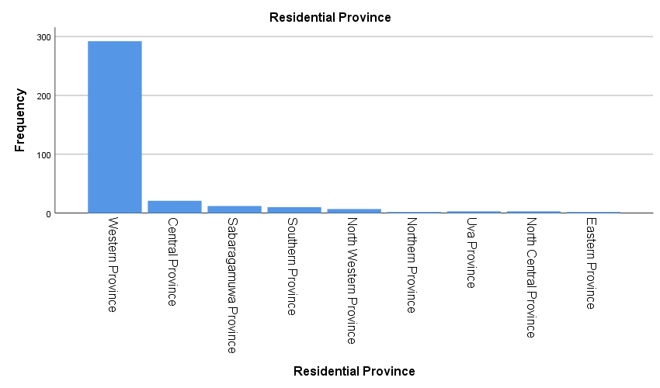

Figure 6:Residential province

According to Sri Lankan provinces, the survey respondents are distributed as shown in the statistics above. The Central Province comes in second with ***6%*** of the participants, with the Western Province accounting for ***83%***. ***3.4%, 2.8%, 2.0%, 0.6%, 0.9%, 0.9%,*** and ***0.6%***, respectively, of participants, were from the provinces of Sabaragamuwa, the Southern, the North Western, the Northern, the Uva, the North Central, and the Eastern.

1. **Are you purchasing daily goods from Supermarkets**

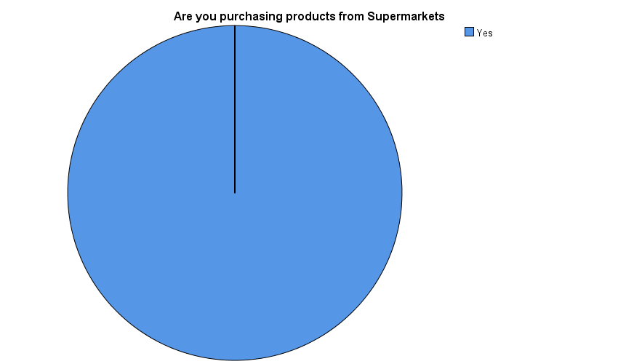

Figure 7:Are you purchasing daily goods from Supermarkets

The data reveals that all ***352*** survey respondents acknowledged they made their purchases from supermarkets, demonstrating the importance of supermarkets in Sri Lanka's retail market for FMCG goods.

1. **If yes, What are the major supermarkets that the Person is Using**

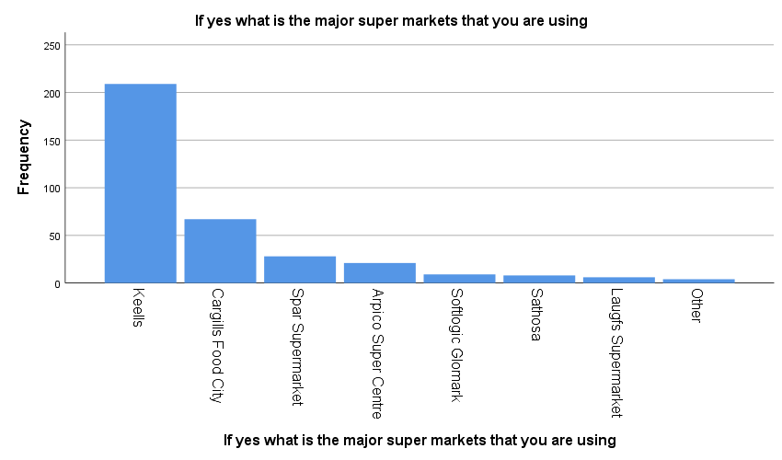

Figure 8:If yes, what are the major supermarkets that the Person is Using

The information reveals which big-box stores participants who shop at supermarkets most frequently frequent. ***Keells*** was mentioned by ***59.4%*** of respondents as their go-to grocery store, followed by Cargills Food City ***(19%)*** and Spar Supermarket ***(8%).***

Arpico Super Centre, Softlogic Glomark, Sathosa, Laugfs Supermarket, and other supermarkets received the remaining percentages.

1. **I want to purchase FMCG (fast-moving consumer goods) products in supermarkets**

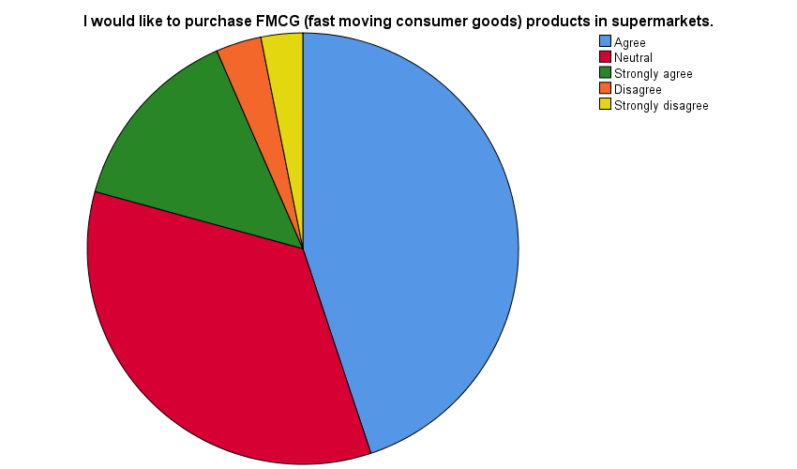

Figure 9:I want to purchase FMCG (fast-moving consumer goods) products in supermarkets

This survey question inquires about the respondents' preference for shopping for FMCG items in supermarkets. ***158 (44.9%)*** of the 352 participants stated they would prefer to buy FMCG products in supermarkets, while 121 ***(34.4%)*** expressed no opinion. 12 ***(3.4%)*** disagreed, 11 ***(3.1%)*** strongly disagreed, and 50 ***(14.2%)*** strongly agreed.

1. **Purchase FMCG products from supermarkets soon**



Figure 10:I will purchase FMCG products from supermarkets in the near future

The information supplied shows the frequency and percentage distribution of responses to a survey question about consumers' propensity to shop at supermarkets for fast-moving consumer goods (FMCG) in the next months.

Of the ***352*** respondents, ***186 (52.8%)*** indicated that they will buy FMCG products from supermarkets soon, while ***102 (29.0%)*** expressed no opinion. Only ***48 (13.6%)*** respondents strongly agreed with the statement, compared to ***13 (3.7%)*** and ***3 (0.9%)*** who strongly disagreed.

The running total percentage of responders up to each response category is shown in the cumulative percent column. As an illustration, ***52.8%*** of respondents agreed or agreed strongly, while ***81.8%*** of respondents agreed, were indifferent, or agreed strongly.

1. **Recommendation to Purchase FMCG Products from Supermarkets**

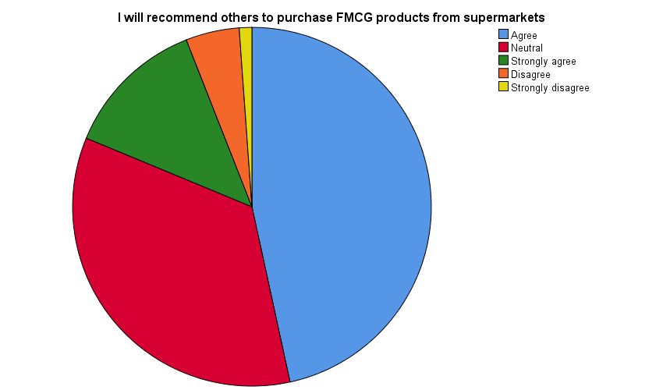

Figure 11:Recommendation to Purchase FMCG Products from Supermarkets

According to the participants' comments, the majority of them ***(46.6%)*** appear to agree that they would advise others to buy FMCG products from supermarkets, with ***34.7%*** remaining neutral and ***12.8%*** strongly concurring. On the other hand, just ***1.1%*** strongly disagree with this statement, and only ***4.8%*** disagree.

1. **Motivation to purchase FMCG products from Supermarkets**

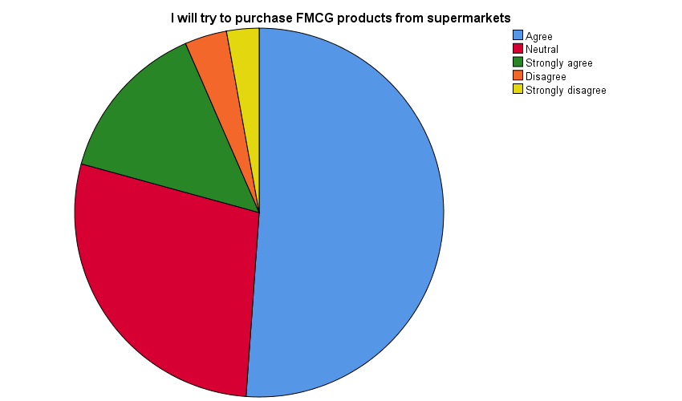

Figure 12:Recommendation to Purchase FMCG Products from Supermarkets

According to the findings, the majority of participants ***(51.1%)*** declared that they would make an effort to buy FMCG items from supermarkets. The statement was agreed with by about 28.1% of the participants, ***14.2%*** strongly, 3.7% disagreed, and ***2.8%*** strongly.

The results as a whole indicate that a sizeable proportion of participants are willing to buy FMCG products from supermarkets.

1. **I In-store Advertisements**



Figure 13:I Look for in-store advertisements

The information supplied shows the frequency and percentage distribution of answers to a survey question on respondents' interest in in-store advertisements.

***187 (53.1%)*** of the 352 respondents agreed that they seek in-store advertisements, and 74 ***(21.0%)*** expressed no opinion. Only 59 respondents ***(16.8%)*** strongly agreed with the statement, compared to 27 respondents ***(7.7%)*** who disagreed and 5 respondents ***(1.4%)*** who severely disagreed.

The running total percentage of responders up to each response category is shown in the cumulative percent column. For instance***, 74.1%*** of respondents either agreed, were indifferent, or strongly agreed, compared to ***53.1%*** of respondents who agreed or strongly agreed.

The majority of respondents appear to be interested in in-store advertisements, according to the statistics, with a lesser minority neutral or opposed to them.

1. **Promotional offers and signage in Supermarkets gain my attention**

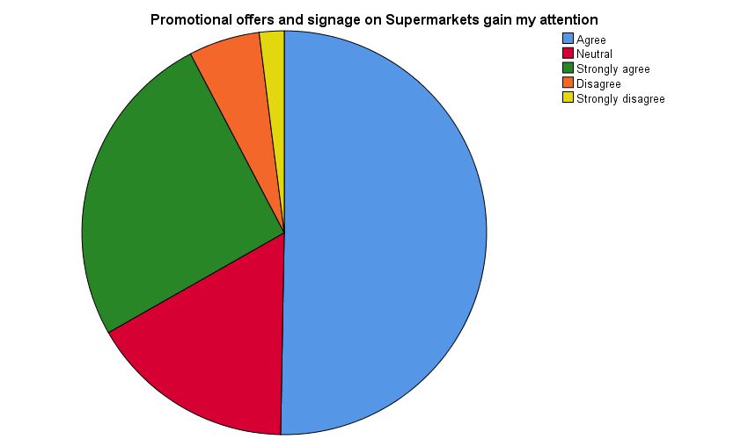

Figure 14:Promotional offers and signage in Supermarkets gain my attention

According to the results, a sizeable portion of the participants ***(76%)*** either agreed or strongly agreed that advertising and special offers in supermarkets catch their attention. ***Only 8%*** of the participants objected or strongly disagreed with the statement, while ***17%*** of the participants were neutral.

This shows that advertising and special offers are efficient marketing tools for supermarkets to draw in and keep customers.

1. **Purchase FMCG products based on the special offers that are put inside stores**



Figure 15: Purchase of FMCG products based on the special offers that are put inside stores

According to the poll results, it appears that many respondents buy FMCG products from supermarkets and are favorably affected by advertising and special offers in the stores. The majority of respondents said they would or were very likely to advise others to buy FMCG items from supermarkets, and they would also try to buy FMCG items from supermarkets.

A sizeable portion of respondents, meanwhile, disagreed with these claims or were neutral about them. In addition, while many respondents concurred that they buy FMCG products based on promotional offers in stores, a sizable portion also disagreed with this assertion. Overall, it appears that advertising and special offers work well to attract customers, but not consistently enough to convert them into buyers.

1. **I purchase more FMCG products unintentionally which are on sale**

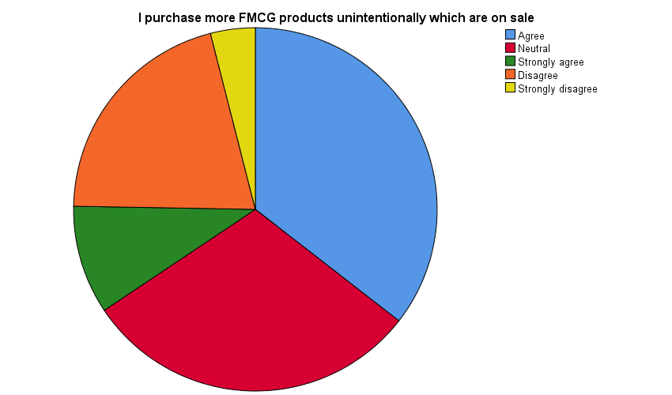

Figure 16:I purchase more FMCG products unintentionally which are on sale

The information provided shows the frequency and percentage distribution of answers to a survey question about buying FMCG goods that were accidentally on sale.

Out of the 352 respondents, ***125 (35.5%)*** said they unintentionally buy more FMCG products when they are on sale, while 106 ***(30.1%)*** gave a neutral response. 34 ***(9.7%)*** respondents strongly agreed with the statement, compared to 73 (20.7%) and 14 (4.0%) who strongly disagreed.

The running total percentage of responders up to each response category is shown in the cumulative percent column. For instance, 65.6% of respondents either agreed, were neutral, or strongly agreed, compared to 35.5% who agreed or strongly agreed.

1. **The promotional display attract me to visit the supermarket again**



Figure 17:The promotional display attract me to visit the supermarket again

According to the survey, ***25.6%*** of respondents were neutral on the topic, while 17.3% strongly agreed, leaving 45.2% of respondents in agreement that promotional displays encourage them to shop at the supermarket again. 2.8% of respondents strongly disagreed, and 9.1% disagreed.

The average response was 2.11, with a variance of 0.83 and a standard deviation of 0.91.

1. **Brightly-lit supermarkets are more attractive than dimly-lit stores**

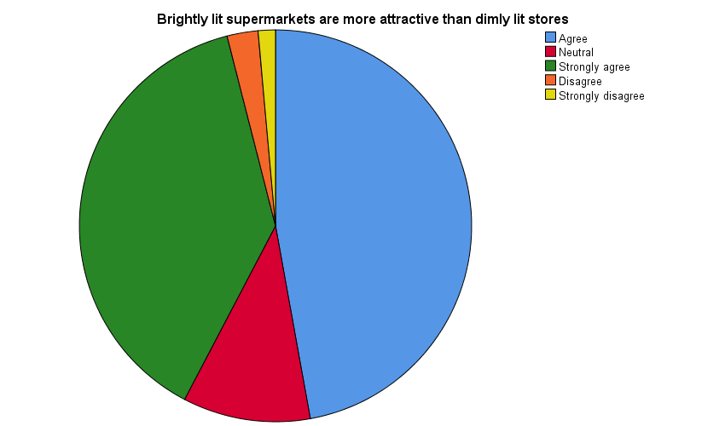

Figure 18:Brightly lit supermarkets are more attractive than dimly lit stores

The information above shows the findings of a survey in which participants were asked to rate how much they agreed or disagreed with a particular statement.

The majority of responders either agreed with the information or strongly agreed with it, suggesting that it was positively phrased. In particular, ***47.2%*** of respondents agreed with the statement, and 38.4% strongly agreed.

The fact that so few respondents (2.6%) or (1.4%), respectively, strongly disagreed with the statement suggests that it was generally well accepted. Only 10.5% of respondents indicated they were unclear of their position on the statement by selecting the neutral option. Overall, it seems that the majority of respondents thought highly of the statement.

1. **Good lighting impacts the atmosphere of the supermarket**

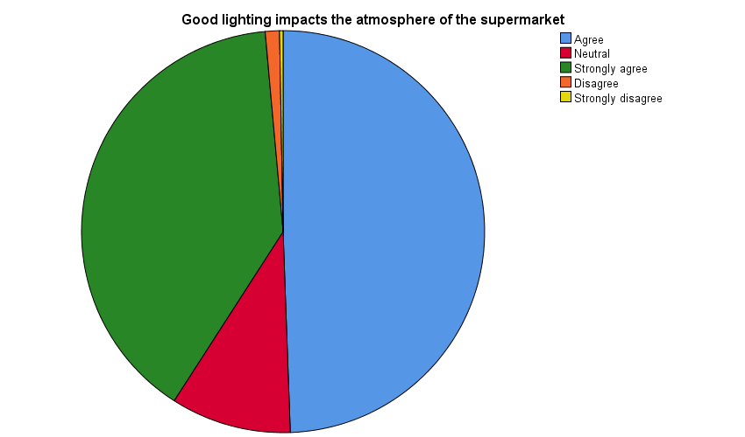

Figure 19:Good lighting impacts the atmosphere of the supermarket

The information above shows the findings of a survey in which participants were asked to rate how much they agreed with a claim about how adequate lighting affects a supermarket's environment. The majority of respondents, who indicated their agreement with the statement with either a yes ***(49.4%)*** or a strong yes ***(39.5%)***, concur that appropriate lighting enhances the ambiance of a supermarket.

A tiny percentage of survey participants disagreed ***(1.1%)*** or strongly disagreed (0.3%) with the assertion, indicating that they do not think decent lighting is essential to establishing a pleasant ambiance in a supermarket. A tiny portion of respondents ***(9.7%)*** also stated that they were undecided or had no opinion by selecting the neutral option.

1. **The use of lights in different colors and brightness to decorate the supermarket would attract me to products that are seen and swing my mood toward buying**

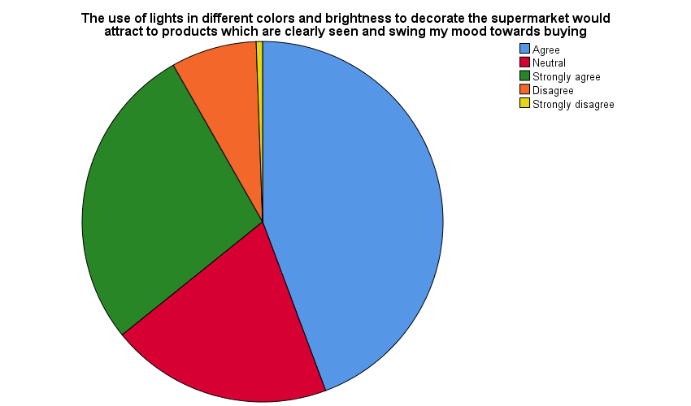

Figure 20:The use of lights in different colors and brightness to decorate the supermarket would attract me to products that are seen and swing my mood toward buying

According to the research, the majority of respondents either agreed or strongly agreed that decorating a supermarket with colorful and brilliant lighting draws attention to the products and affects customers' intentions to make purchases.

A sizeable portion of respondents chose the neutral response, whereas a much smaller proportion agreed or strongly agreed with the statement.

Overall, the findings imply that attracting people and influencing their shopping choices at a supermarket may be accomplished by employing colorful and bright lights.

1. **Purchase FMCG products from supermarkets because of the way they are arranged on the shelves**

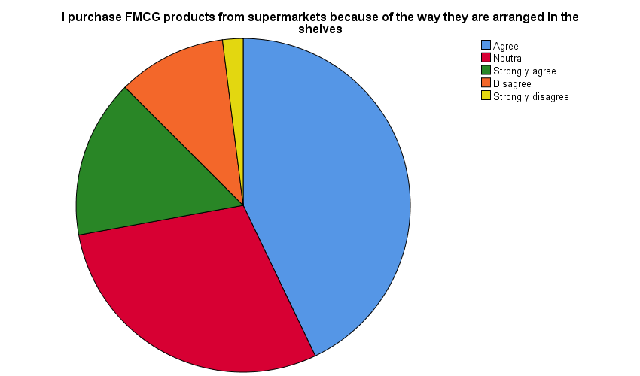

Figure 21:Purchase FMCG products from supermarkets because of the way they are arranged on the shelves

According to the statistics, ***42.9%*** of respondents and 15.3% of them strongly agree that the positioning of products on supermarket shelves affects their decisions to buy FMCG.

However, a sizable portion of respondents (29.3%) opted for the neutral response, whereas just 10.5% and 2.0% of respondents strongly disagreed with the statement. Overall, the findings imply that while not all respondents may be affected by product placement on shelves, many may.

1. **When there is an eye-catching display, I end up purchasing that product**

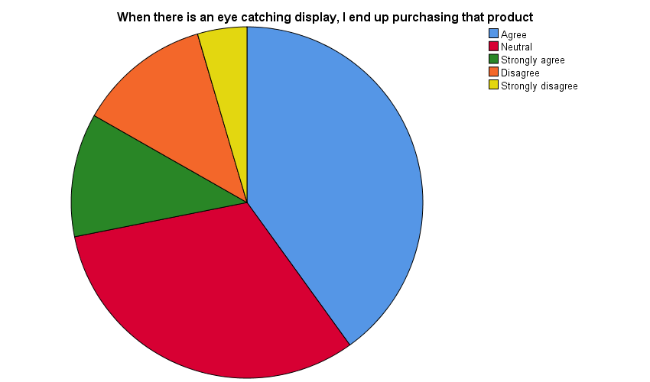

Figure 22:When there is an eye-catching display, I end up purchasing that product

According to the statistics, a sizable portion of respondents either agreed ***(40.1%)*** or strongly agreed (11.4%) with the claim that attention-grabbing displays can affect their shopping decisions. However, a sizable portion of respondents ***(31.8%)*** selected the neutral response, indicating they were unsure or did not have a strong view of the subject.

Fewer respondents disagreed ***(12.2%)*** or strongly disagreed ***(4.5%)*** with the statement, indicating that they do not think attractive displays affect their purchasing decisions.

Overall, the findings imply that an eye-catching display can be an efficient strategy to persuade a significant part of respondents to make a purchase, albeit a sizeable minority is neutral or disagrees with the assertion.

1. **I like purchasing products that are displayed on the billing counter**

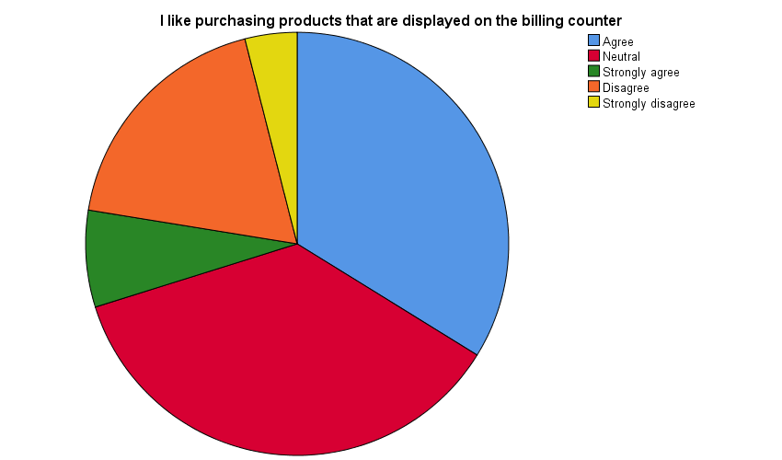

Figure 23:I like purchasing products that are displayed on the billing counter

The information given is a frequency and percentage distribution of answers to a survey question about buying items shown on the billing counter.

Out of the 352 respondents, ***119 (33.8%)*** said they enjoy buying items that are at the checkout counter, and 128 ***(36.4%)*** gave an indifferent response. Only 26 ***(7.4%)*** respondents strongly agreed with the statement, compared to 65 ***(18.5%)*** and 14 ***(4.0%)*** who strongly disagreed.

The running total percentage of responders up to each response category is shown in the cumulative percent column.

As an illustration, ***96.0% of respondents either agreed***, were neutral, strongly agreed, or disapproved, compared to 70.2% who either agreed, were neutral, or strongly agreed.

1. **Purchase products from the supermarket based on the convenience of the product placed**

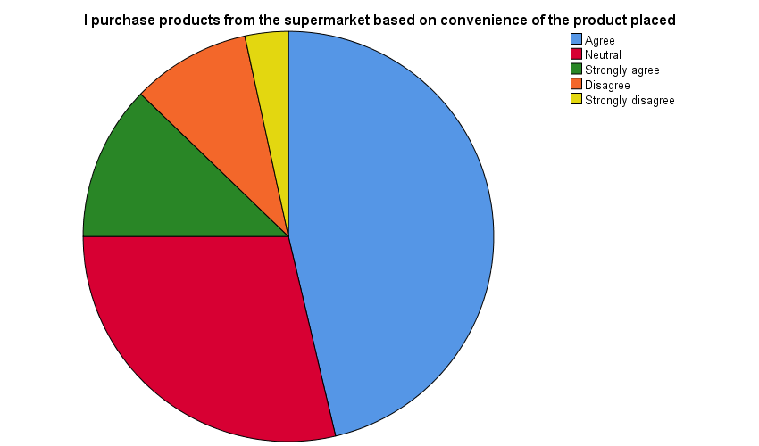

Figure 24: Purchase products from the supermarket based on the convenience of the product placed

According to the statistics, the majority of respondents either agreed (46.3%) or strongly agreed (12.2%) with the statement that they buy products from the grocery store because of the placement's convenience. However, a sizable portion of respondents (28.7%) selected the neutral response, indicating they were unsure or did not have a strong opinion.

Fewer respondents (9.4%) strongly disagreed (3.4%) with the statement, suggesting that they do not think the ease of product placement affects their purchasing decisions.

Overall, the findings indicate that although a sizeable minority of respondents are neutral or disagree with the statement, convenience of product placement may be a key factor for many respondents when making purchasing decisions.

1. **A good supermarket layout makes me easy to find desired products**

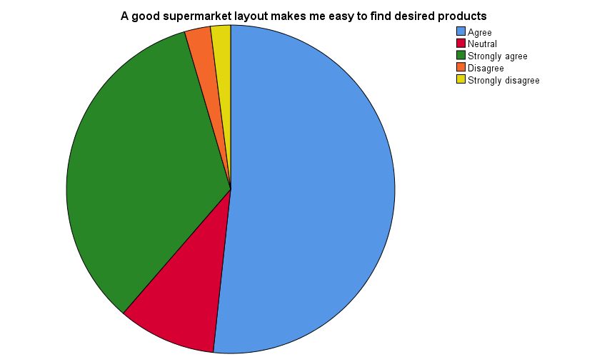

Figure 25:A good supermarket layout makes me easy to find desired products

According to the findings, ***most respondents*** either ***agree or strongly agree*** that a well-designed supermarket makes it simple for them to locate requested goods. Notably, 34.1% agree, and 51.7% strongly agree. Only 2.6% of those surveyed said they disagreed with this statement, and 2% said they strongly disagreed.

This shows that a well-designed layout is crucial to giving clients a satisfying shopping experience. The small fraction of responders who disagree or strongly disagree may profit from a redesigned design or better signage to make it easier for them to find their way around the business.

1. **Store layout which will allow moving easily**

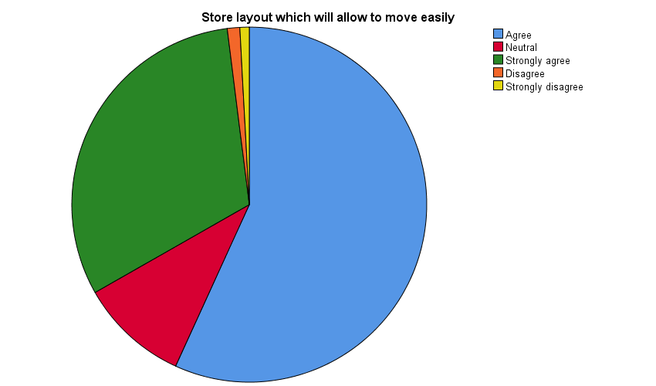

Figure 26:Store layout which will allow moving easily

According to the data, ***56.8%*** of respondents concur that they prefer a retail layout that makes it easy for them to walk around. Only ***1.1%*** of respondents disagree with this statement, ***0.9%*** strongly disagree, and ***31.3%*** strongly agree. The other respondents are all undecided.

1. **Buy products based only after looking around completely**

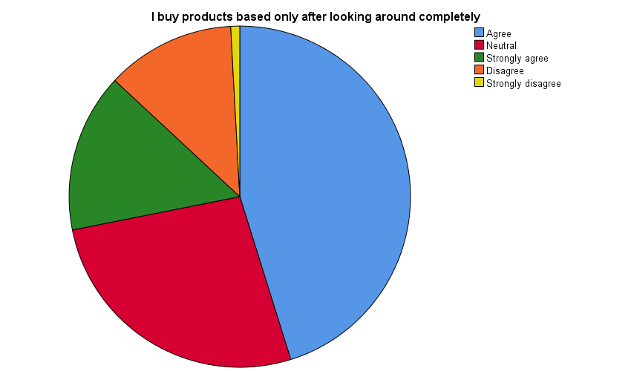

Figure 27:I Buy products based only after looking around completely

The extent to which respondents browse the supermarket before making a purchase is the subject of this survey question. The majority of respondents ***45.2% agreed that they only make purchases after browsing the entire store***. Only 0.9% strongly disagreed, while 15.1% strongly agreed, 12.2% disagreed, and 26.7% had a neutral opinion.

This shows that, overall, a sizable proportion of respondents enjoy perusing the entire store before making a purchase, whereas a smaller proportion may not.

1. **Tend to buy more products that are catchy to me when I pass aisles(passenger pathway)**

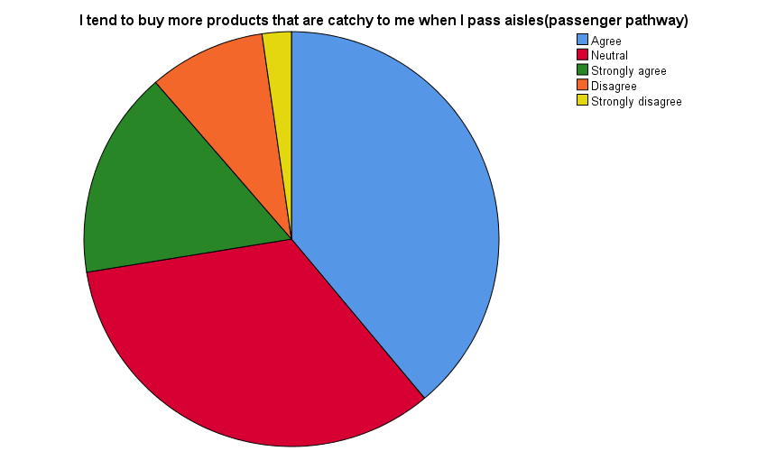

Figure 28:Tend to buy more products that are catchy to me when I pass aisles(passenger pathway)

According to the poll findings, ***38.9%*** of participants agreed that they frequently purchase more items that capture their attention as they go through aisles, whereas 33.5% disagreed and 16.2% strongly agreed. 9.1% of respondents disagreed with the assertion, however, and 2.3% strongly disagreed.

Overall, research appears that appealing product displays in the aisles can affect customers' purchasing decisions for a sizeable fraction of supermarket patrons.

# 4. References

Anon., 2023. *Bar Graph Vs Pie Chart: Select The Proper Type For Your Data.* [Online]   
Available at: https://www.fusioncharts.com/blog/bar-graph-vs-pie-chart-select-the-proper-type-for-your-data/#:~:text=A%20pie%20chart%20is%20preferred,charts%20are%20the%20right%20choice.  
[Accessed 04 04 2023].

Anon., 2023. *How to Choose Between a Bar Chart and Pie Chart.* [Online]   
Available at: https://chartio.com/learn/charts/how-to-choose-pie-chart-vs-bar-chart/  
[Accessed 06 04 2023].